Specifications / Net Price Quotation
SWAB Pioneer ALSF-96
Fiberglass Utility Body and Conversion

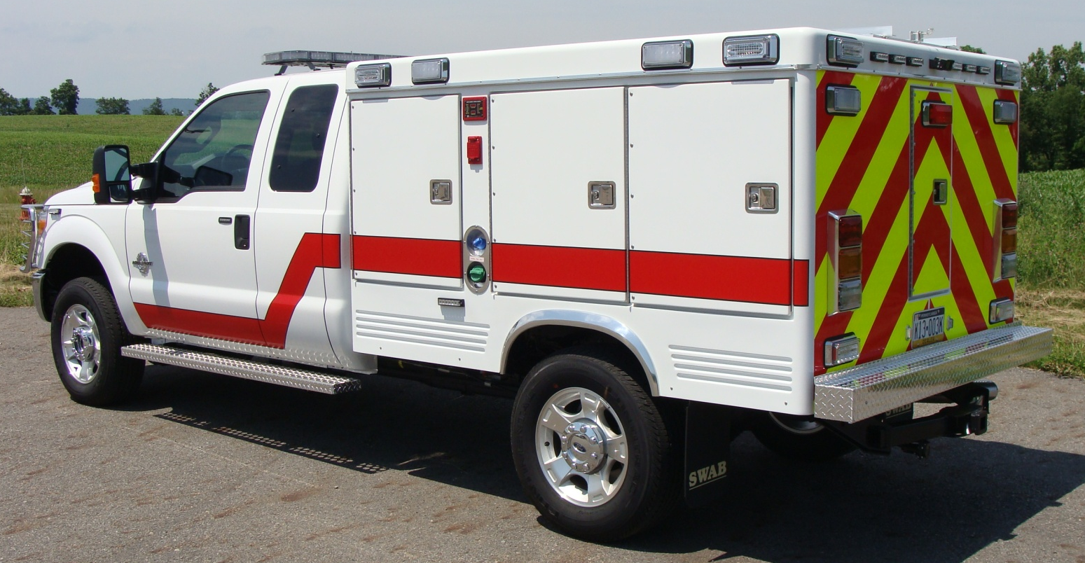
For:
Swab Wagon Company, Inc.
44 S. Callowhill Street, PO Box 919
Elizabethville, PA 17023-0919

INTENTION
The following specifications are submitted in order to describe and specify the design, construction, materials and equipment to be utilized and installed in the fabrication of a Quick Response unit to be used in the Emergency Services field.

DESCRIPTION
SWAB PIONEER SERIES fiberglass truck body having six (6) equipment storage compartments, three (3) accessible from left or right side of body, with/without rear compartment. Fabricated of 100% reinforced fiberglass of "one-piece" construction to eliminate seams and cracks.

CHASSIS INFORMATION
A standard “Pick-Up Chassis” having a wheelbase of sufficient length to provide a 56” cab-to-axle (C/A) dimension is required. Chassis must be equipped with a single rear wheel and mid-ship fuel tank. All other options are at the customer’s preference. Current acceptable chassis are: Chevy/GMC 3500HD, Ford F-350, or Dodge Ram 3500*.

Chassis to be supplied by: Swab Wagon Company, Inc.

YEAR: 2014 MAKE: Ford MODEL: F-350 XLT Ext Cab 4x4

EQUIPMENT AND OPTIONS:
6.7L 4V Power Stroke Diesel V8 6-Spd Automatic Transmission
3.31 Axle Ratio XLT Value Package
Pickup Box Delete Carpet Delete
11,400lb GVWR Package Dual Alternators
PowerScope Trailer Tow Mirrors Electronic Shift-On-The-Fly 4x4
18” Cast Aluminum Wheels

WEIGHT
The weight of the basic fiberglass unit exclusive of optional items and equipment – 920 pounds.

CONSTRUCTION
Full fiberglass-reinforced plastic "one-piece" construction throughout with smooth finish. Color to be Oxford White gel coat molded into body during fabrication.

Four (4) tubular stainless steel cross-members molded into bottom of unit. Sides skirted with cut-outs at rear wheels of proper size to permit easy removal of wheels when required. Roof section to be reinforced underneath with channel for added strength.

Polished aluminum rain gutter molding installed around entire unit at roof line to prevent "run-off" from body roof into storage compartments.

Bottom of unit to be completely enclosed to reduce heat build-up around compartments and to provide a "dead-air" insulating space around compartments.

BODY DIMENSIONS
The overall body dimensions are: 98” Long x 78” Wide x 54” High.

BODY FLOOR PLAN OPTIONS

Customer’s Choice: Floorplan “A”
Choose from 10 “standard” compartment configurations (see chart on next page), or contact your sales representative to discuss a custom layout to fit your needs.

COMPARTMENTS
Each body side compartment to be of "one-piece" molded fiberglass construction without cracks or seams to prevent dirt and/or moisture from entering compartment.

Rear "backboard" compartment to be molded fiberglass in multiple sections with each seam sealed with proper sealant to prevent dirt and/or moisture from entering compartment.

Compartment opening is to be fully gasketed with tubular closed-cell neoprene type material, installed in such a manner as to make full contact with doors when closed and latched with door locking hardware.

Body side compartments to have 16 gauge steel plates molded into fiberglass walls to serve as reinforcement plate for optional shelving. Body side compartments to have Dri-Dek heavy-duty poly vinyl tiles installed on compartment floors to provide dry/skid free decking.

Dri-Dek Color: RED

COMPARTMENT DOORS
Each compartment door to be of full fiberglass-reinforced plastic construction. Doors are to have smooth finish on both sides.

Doors to be hinged on full-length special stainless steel hinges to permit full opening of door.

Doors equipped with key-locking 6" “D” ring exterior handles, polished stainless steel and keyed alike. Doors are to be secured by three (3) point system using rod and guide for two (2) points and cam latch for center point.

FEDERAL & STATE DOT LIGHTING
All Federal and State required body marker lights, reflectors, dual back-up lights and dual license lights installed.
REAR DOT LIGHTS: Installed in a Code 3 polished DOT housing
Brake Lights – Code 3 LED w/ Center High Mount 3rd Brake Light
Turn Signals – Code 3 Sequential LED Turn Arrow
Reverse Lights – Code 3 LED Back-Up

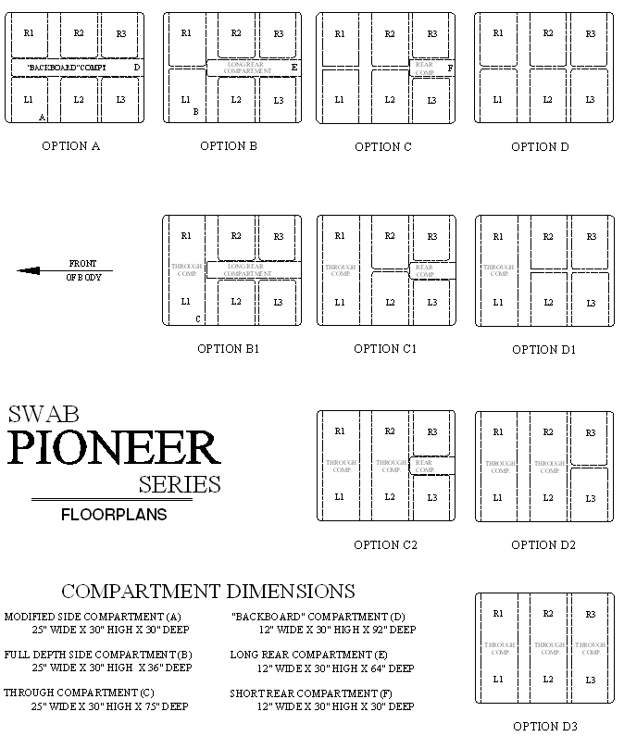

REAR BUMPER & MUD GUARDS
Rear bumper to be fabricated from 3” steel channel/tube and reinforced to truck frame. Bright aluminum treadplate overlay installed on steel bumper and secured with required fasteners.

SWAB logo mud and splashguards installed at rear wheels.

MOUNTING
Body mounted onto truck chassis frame using three (3) mounting-points on each side of chassis frame. Each body mounting point is to have a rubber mounting isolator installed to reduce excess vibration and strain on body. Fiberglass body is to be mounted as low as possible consistent with proper tire clearance underneath but no lower than cab roof.

ELECTRICAL

General Overview (12VDC)
Electrical system installed using minimum 14 gauge WGXL Crosslink Thermoplastic insulated stranded wire to each load carrying circuit. Each circuit color-coded, maintaining individual wire color from circuit breaker to load. Wiring installed in high temperature Zip Loom (300 degree rating) where exposed. All connections made with solderless terminals. Wiring harness installed with all required attachments and grommets installed where wiring passes through metal or fiberglass.

General Overview (110VAC)
110-volt wiring installed as required with minimum 12 gauge SJ type cable with waterproof junction boxes as required, box connections and wiring clips. All required attachments and grommets installed where wiring passes through metal or fiberglass.

WARNING LIGHTS AND SIREN EQUIPMENT
All customer specified warning light and siren equipment to be installed in accordance with manufacturer's installation instructions.

Light/siren circuits to be switched through a solenoid or relay to protect cab console/panel switch. All required weatherproof gaskets and mounting brackets installed.

DELIVERY PREPARATIONS
Customer's chassis oil, grease levels checked and filled to recommended levels. Anti-freeze solution brought to original level after installation of body heater system, if so equipped. Batteries fully charged. Unit weighed and road tested. All auxiliary equipment serviced and tested for proper operation. Unit is to be thoroughly cleaned inside/outside.

INSPECTION(S)
Swab Wagon Company, Inc. requests that customers inspect progress on their new apparatus twice during the build process. The first inspection should be done upon mounting of the body onto the chassis. At this point, the customer should select placement of items such as electrical outlets, special shelves, junction boxes, the battery conditioner, switch layout, placement of hand lights, etc. The second inspection should be done prior to delivery of the completed apparatus. At this inspection, the customer should inspect the craftsmanship of the unit, verify that the specifications/design have been met, and can also make any final requests for minor changes and additions.

All travel expenses related to inspections shall be incurred by the customer. Swab Wagon Company does offer our company camp facility, Happy Valley, free of charge as a courtesy to our out-of-town customers.

The customer is welcome to perform as many inspection visits as they wish (within reason). All inspections are to be scheduled in advance with Swab sales personnel. Inspection teams are requested to not exceed six (6) fire company personnel.

Customers who fail to perform any inspections of their unit while in production, forfeit the right to request any changes (free of charge) to the placement of items, not specifically spelled out in the specifications, after the completed unit is delivered.

CHANGES & ADDITIONS
All Changes & Additions to contract, including additional charges or credits, shall be submitted to customer for approval. All submissions, accepted or rejected, shall be returned to SWAB. In the case of an accepted Change & Addition, the work shall not be implemented until such time as the necessary documents have been returned to SWAB and the conditions (terms), if any, of the order have been satisfied.

WORKMANSHIP
The design, construction and finish to above body and equipment to equal or exceed previous SWAB rescue/squad bodies.

WARRANTY
[A] Body and specified equipment is warranted free of defects for a period of two (2) years from date of delivery. Body manufacturer shall be responsible for defects in fiberglass-plastic materials during this same period of time.
[B] Auxiliary equipment (i.e. heat/cool units, warning lights, etc.) to carry respective manufacturer's warranty with purchasing agency responsible for labor cost to replace defective equipment.
[C] Electrical and paint work to be warranted for two (2) years from date of delivery to original owner for 100% of the expense to perform required replacement/repair to correct defects in electrical design/installation and/or paint workmanship.
[D] Upon notification, SWAB will perform required repair/replacement work under the following procedures: (NOTE - SWAB reserves the right to stipulate which procedure warranty will be performed by.)
[D1] At customer’s location by SWAB service personnel.
[D2] At customer’s location by SWAB approved/qualified outside contractor upon receipt by SWAB of quotation for said work.
[D3] At SWAB facilities in Elizabethville, PA in which case the unit will be returned to SWAB at owner’s expense.
[E] All claims for warranty repairs must be filed with SWAB PRIOR to repairs being started. All claims must be filed within the above specified warranty periods. SWAB reserves the right to deny any and all warranty claims that have been started and/or completed without proper notification to SWAB.
[F] All warranties voided by accident repair(s), body modification(s), and/or transfer to new chassis by a party other than SWAB, unless approved in writing by SWAB. All warranties voided upon transfer of ownership to another party from original owners.
[G] Electrical warranty voided by alterations and/or modifications to electrical system when performed within the warranty period when accomplished by party other than SWAB unless approved in writing by SWAB. Repairs by others of chassis original electrical system does not constitute a warranty void.

COMPLETION ESTIMATE
Completion of a Pioneer unit is estimated at 12 weeks from the receipt of the chassis, providing the body has been produced prior to receipt of chassis. SWAB will not be held responsible for delays caused by chassis production, or delays in material delivery from customer or vender supplied equipment.

DETAILED SPECIFICATIONS
These detailed specifications and/or drawings are provided for the purpose of outlining details of manufacture and production and shall remain the property of SWAB. Specifications and/or drawings shall not be transferred to other agencies, associations, or individuals without the express permission being granted by SWAB. These detailed specifications and/or drawings may be used in the preparation of public papers. Specifications are subject to change without notice.

INSURANCE
SWAB does not carry insurance on Customer owned vehicles (cab & chassis); and as such will not be liable to loss or damage due to fire, theft, vandalism, windstorm or any other Acts of God.

MATERIAL / EQUIPMENT SUBSTITUTION
Due to the constant updating and improvement of designs and equipment by chassis manufacturers, and subsequent changes in model numbers and designs of chassis-specific after-market equipment items, Swab Wagon Company, Inc. reserves the right to substitute model numbers of equipment items for the specific model year of the chassis being supplied without notice to the customer. Due to constant updating and improvements of designs by our suppliers, Swab Wagon Company reserves the right to supply equipment items equal or superior to the model number of the equipment items contained within these specifications, without notice to the customer.

CUSTOMER SUPPLIED EQUIPMENT / MATERIAL
Customer supplied equipment must be received by SWAB no later than sixty (60) days from date contract has been awarded. Materials delays can and will cause production delays. SWAB will not be held to production deadlines when customer supplied materials are not received by SWAB per the sixty (60) day receipt requirement. All material shipments must bear the job (customer) name on the packing list.

Customer will furnish to SWAB an itemized check list of all customer supplied materials that will be shipped to SWAB. Check list must be furnished to SWAB when the materials are ordered.

All claims for materials received in a damaged condition shall be the responsibility of the customer. The customer shall also be responsible for securing RMA (return materials authorization), also known as RGA (returned goods authorization), and cost incurred by SWAB for return material shipments.

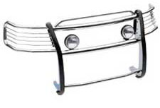
CHASSIS MODIFICATIONS & EQUIPMENT

GRILL GUARD
One (1) Westin Sportsman Grill Guard #45-2370, installed per manufacturer’s installation instructions. Grill Guard to have a polished stainless steel finish.

NFPA COMPLIANT CAB STEPS
One (1) pair of running boards fabricated and installed onto chassis. Running boards are to be fabricated from Perf – O – Grip walkway material. Custom brackets to be fabricated to mount the step to the chassis. Front, rear, and outer edges of the step are to be covered in aluminum treadplate material.

REAR VIEW CAMERA
One (1) Hanscom K. #7111N GPS Navigation/Back Up Camera System installed per manufacturer’s installation instructions. System to include a 7” Navicam 7300 LED monitor and a HC IR250 Color Infrared camera w/ audio. Monitor will be installed in place of the factory rear view mirror.

PIONEER BODY

MODIFICATIONS & EQUIPMENT

SLAM-SHUT LATCHES WITH PADDLE STYLE HANDLES AND POWER LOCKS
Doors equipped with key-locking paddle exterior handles, polished stainless steel and keyed alike. Doors are to be secured by a cam lock and striker system using spring loaded slam-shut latches. Handles to include Power locks that will be wired into the chassis locking system.

*Will replace the D-Ring handle and three (3) point locking system in the Compartment Door Section.

DOOR RETAINERS
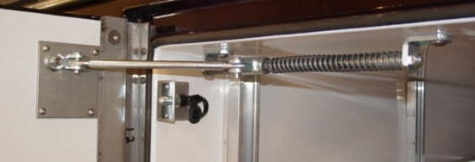
All body side doors equipped with Cleveland double-spring cadmium-plated retainers to hold doors at 90-degrees to body side when open. Rear compartment door to have nylon strap door retainer installed with two (2) footman’s loops if the body is equipped with a rear facing compartment.

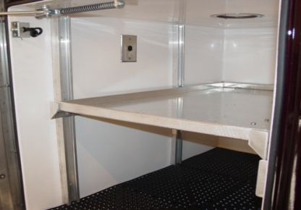
ADJUSTABLE COMPARTMENT SHELVING
One (1) adjustable shelf installed in customer specified side compartment. Adjustable shelf to have 1" double break lip on front and back edge, left and right edge to be 1" single break lip. Shelves are to be installed on Kindorf "C" type aluminum side wall "shelf track" and have 1 1/4" x 3/16" full depth side brackets with end gussets. Kindorf rail clips and fasteners provided for each bracket.

TOTAL QUANTITY: Four (4) LOCATIONS: L1 L2 R1 R2

SLIDE-OUT TRAY
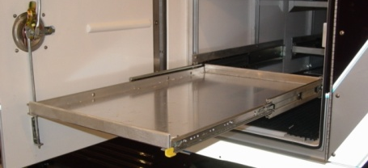
One (1) slide-out tray installed in customer specified compartment. Tray and slides installed on adjustable shelf track. Tray to have 1” double break lip on front and back edge, left and right edge to be 1” single break lip. Two (2) heavy-duty ball-bearing slides installed, one (1) with hold-open mechanism. Slides have a 300lb maximum capacity.

TOTAL QUANTITY: One (1) LOCATION: L1

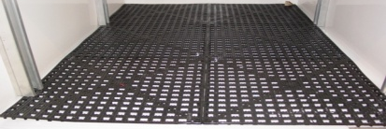
DRI-DEK FOR ADJUSTABLE SHELVING AND SLIDE-OUT TRAYS
Heavy poly vinyl tiles installed on adjustable shelf/slide-out tray to provide dry/skid free decking. Dri-Dek is standard on body side compartment floors and will be the same color as the standard color chosen above.

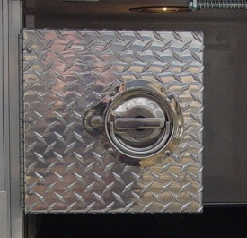
PHARACEUTICAL LOCK BOX
One (1) pharmaceutical lock box fabricated from .125 aluminum with stainless steel piano hinge and locking 6” D-handle latch. Lock box securely bolted to shelf track with a minimum of four (4) bolts. Lock box designed to be mounted in any compartment with existing shelf track. Lock box standard size is approximately 12” wide X 12” high X 22" deep. Custom sizes are available.

TOTAL QUANTITY: One (1) LOCATIONS: R2

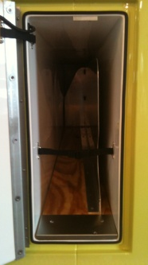
BACKBOARD COMPARTMENT DIVIDER/RETAINER
Backboard divider installed in backboard compartment capable of securely retaining customer supplied backboards/stokes basket. Divider is to be fabricated from .063 aluminum and 1/2" CDX plywood. Velcro strap installed to secure board(s) and/or stokes basket within compartment. The compartment layout is to be approved prior to the start of fabrication.

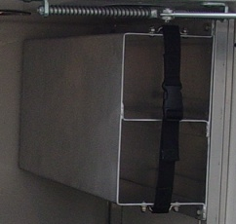
OXYGEN BOTTLE STORAGE RACK
One (1) Oxygen bottle storage rack capable of storing two (2) "E" or two (2) "D" oxygen bottles (or 1 of each) up to 5 1/4” diameter. Fabricated from .100 aluminum and installed in customer specified compartment. Bottle rack is designed to be mounted in any compartment with existing shelf track.

TOTAL QUANTITY: One (1) LOCATIONS: R2

OXYGEN BOTTLE STORAGE CABINET
One (1) bottle storage rack capable of storing four (4) "standard E" size oxygen cylinders. Fabricated of .125 aluminum and installed between compartments R1 and R2 with external body access door.

COMMAND DESK
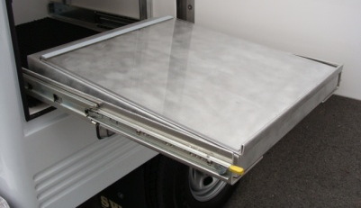
One (1) slide out command desk fabricated from aluminum with clear plexiglass hinged overlay. Desk top is to be angled toward front with a storage area below. Desk mounted on slides and vertical adjustment track. Desk dimensions are approximately 23" wide, 2" height in front - 4" height in rear and a depth of 24".

TOTAL QUANTITY: One (1) LOCATIONS: R3

WHEELHOUSING FENDERETTE
Cast Products Model C1185-3 polished aluminum fenderette installed, with concealed hardware, on body at rear wheel body cut-outs.

STOKES BASKET STORAGE RACK, ROOF MOUNTED
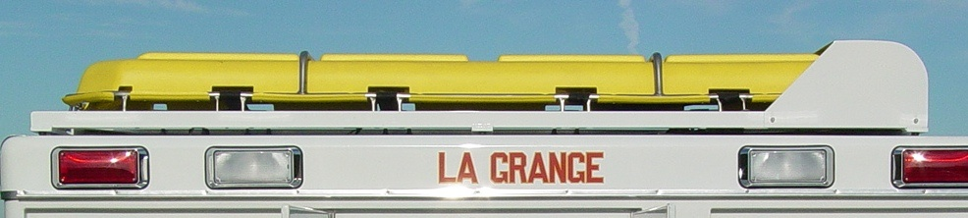
One (1) roof mounted storage rack for customer supplied stokes basket. Aluminum rails installed on roof to guide stokes basket into protective hood. U-shaped brackets with quick-release pins installed at rear of body to secure basket to roof. Front protective hood detachable from roof for access to service panel. Storage rack painted to match body and/or roof color.

One (1) Junkin JSA-200 Plastic Stretcher supplied and installed in above roof mounted rack.

12VDC ELECTRICAL EQUIPMENT - UTLITY

EMERGENCY SERVICES PACKAGE
*PACKAGE IS REQUIRED IF ADDING ANY ADDITIONAL ELECTRICAL EQUIPMENT TO UNIT.
Cab Center Console -- One (1) aluminum, floor-mounted/ between-seat switch console installed with switch panel and rearward open map/book area. Console to be constructed of 1/8” smooth aluminum with lid constructed of ½” black marine grade plastic. Console to be painted with Zolatone series 20 in their Black Onyx color. Console to include lighted type rocker switches with back-lite labels for all specified 12VDC loads.

Ventilated Electrical Enclosure -- One (1) ventilated enclosure to house all 12-volt relays, circuit breakers, and power supplies constructed and installed in compartment R-1. 12v electrical system to be an ISIS multiplex system. Each component identified by number/color and function and listed within control panel. Main service cable shall be 1/0 stranded insulated cable, rated to 210 amps continuous service and protected by a 200 amp automatic reset circuit breaker. Enclosure to provide for ease of transfer of body/equipment to new chassis.

Battery Switch -- One (1) Transportation Safety Devices CDR-357 automatic battery switch mounted in enclosure and connected to chassis batteries and 12VDC system. Automatic switch interfaced with chassis ignition system. Switch to engage/disengage conversion utilities only. Chassis electrical system to remain unaltered. Automatic switch to disengage conversions utilities through internal timer after ignition has been turned off.

LED STRIP COMPARTMENT LIGHTING
Two (2) On Scene Solutions LED compartment strip lights installed on side walls of each side compartment. Each light to be 24” in length and will mount vertically between Kindorf tracks to provide total illumination regardless of shelf or tray position. Rear facing compartment (if equipped) to have Two (2) 4” round LED lights recessed in the ceiling. Lights to be wired to individual door switches.

LED STRIP GROUND LIGHTING
On Scene Solutions LED strip lights installed on the underside of the fiberglass body, under the rear bumper and the chassis cab steps for ground illumination. Ground lights interfaced with ignition switch and transmission neutral safety switch. Lights will activate when ignition switch is on and unit transmission is placed in park/neutral.

12V OUTLET
One (1) or more 12-VOLT accessory outlet installed in customer specified compartment or cab location.

TOTAL QUANTITY: Six (6) LOCATIONS: L1 L3 R1 R3 CAB (2)

12-VOLT CHASSIS SUPPORTED BODY HEATING/COOLING SYSTEM
One (1) Danhard, Inc air conditioning (16,000BTU) and heating (24,000BTU) unit installed in top forward section of body. Body to have removable panel mounted on roof for easy access/repairs. Air channeled to each body side compartment through a fiberglass plenum installed above the compartments. Duct louver installed in compartment for supply air, return louver installed in lower rear side of compartment to recycle heated/cooled air. Unit connected to chassis heating and cooling system with required hoses, connections, relays and cab mounted controls. Hoses routed to body from engine to be shielded with loom. Regulating valve installed in cab heater supply hose to regulate flow to cab and body.

SCENE LIGHTS – 700 SERIES LED
Six (6) Whelen 700 Series (70C0ELZR) Super LED Scene lights installed in upper body corner rail and wired to switch on cab console/panel. Two (2) each installed on left side, right side and rear of unit. Rear scene lights to be interfaced with chassis back-up lights.

COMPARTMENT DOOR “OPEN” INDICATOR
Indicator light installed in cab headliner near the windshield to indicate one or more of the compartment doors are unlatched. All body compartment doors to be wired to indicator light. Light to be a Whelen T0A00FCR with a chrome flange.

BACK-UP ALARM
One (1) Ecco 510 back-up alarm installed on rear of chassis and wired to chassis reverse circuitry.

110VAC ELECTRICAL EQUIPMENT

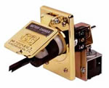
AUTO-EJECT SHORELINE
One (1) Kussmaul 20 amp auto-eject shoreline receptacle installed with Kussmaul weatherproof cover at panel between compartment L-1 and L-2. Wired to one (1) 20 amp duplex receptacle for optional 110-volt electrical items specified by customer.

One (1) matching female plug supplied for installation by customer’s electrician at customer’s facilities.

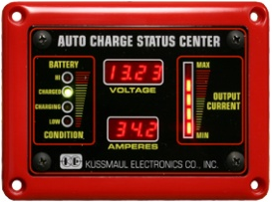
FACEPLATE COLOR: RED

BATTERY CONDITIONER – 20 AMP
*SHORELINE REQUIRED
One (1) Kussmaul 20 LPC (#091-207-12), 20-amp, fully automatic battery charger/conditioner installed in customer specified location. Battery Deluxe Indicator display installed on cab center console, unless otherwise indicated. One (1) 110VAC duplex receptacle installed at conditioner location. Conditioner wired to batteries as required. Location of conditioner to be determined by customer.

110VAC OUTLET
*SHORELINE REQUIRED
One (1) or more 20amp duplex receptacle for 110V electrical items installed in customer specified compartments or chassis cab locations.

TOTAL QUANTITY: Two (2) LOCATIONS: L2 R2

WARNING LIGHTS AND SIRENS

CODE 3 FRONT LIGHT BAR
One (1) Code 3 Defender LED light bar installed on the roof of the chassis. Bar light controlled by the siren and light controller listed below. Bar light configured as follows:
- Model DF52MC, 52” in length
- Two (2) CTR6RW front corner Red/White LED Modules
- Two (2) CTR6R rear corner Red LED Modules
- Seven (7) TC6RW front facing Red/White LED Modules
- Seven (7) TC6RA rear facing Red/Amber LED Modules
- Two (2) TA side facing White LED Alley Light Modules
- Permanent Mount Kit

CODE 3 COORDINATED EMERGENCY LIGHTING SYSTEM (CELS)
One (1) Code 3 C.E.L.S. Package #1 installed per manufacturers installation instructions. CELS package #1 to include the following items:
- Supervisor – Interior windshield mounted visor light with all Red LEDs.
- Citadel – Lights will be custom mounted on the rear roof rail. LEDs are dual color Red/Amber and will serve as both warning lights and also rear Traffic Advisor.
- XT4 – Lights will be installed on the chassis mirrors with Red/White LEDs.
- CELS Control Box – All lights are wired to the control box for coordinated flash patterns and modes.

CODE 3 HIDE-A-BLAST LIGHTS
Four (4) Code 3 Hide a Blast LED lights will be installed. Two (2) White, #HB915W lights will be installed in the Ford headlight housings. Two (2) Red, #HB915R lights installed in the Ford fog light housings. Lights will be wired to the siren and light controller listed below. All front facing flashing white lights will be wired to be disabled when the vehicle is in Park.

CODE 3 WARNING LIGHT PACKAGE
Code 3 LED Warning Light Package installed consisting of the following:
Grill Lights: Two (2) XT6MCRW Multi-Color RED/WHITE lights installed behind the front grill.
One (1) XT604RRRR all RED light bar installed on the underside of the center crossbar on the front grill guard.

Intersection Lights: Four (4) XT6MCRW Multi-Color RED/WHITE lights installed. One (1) on each front chassis fender and One (1) in front of each rear wheel opening.

Body Warning: Six (6) 3712CRBZ-75 PriZm II 3” x 7” RED lights installed. Two (2) lights per side and rear, mounted on the roof rails.
Two (2) 3712CRABZ-75 PriZm II 3” x 7” split RED/AMBER lights installed below the rear DOT light housings.

SIREN AND SIREN SPEAKERS
One (1) Code 3 Z3 siren and lighting controller installed per manufacturer’s installation instructions. All warning lights, light bars, and utility lights will be controlled thru the Z3 controller. Z3 controller to be mounted on the cab center console.

Two (2) Code 3 C3500U 100watt siren speakers installed behind the chassis bumper. Speakers wired to the Z3 Siren.

REMOTE WIRELESS SIREN AND LIGHTING CONTROL
One (1) Code 3 vLink wireless remote control system installed. The vLink system will allow the end user to access the trucks lighting and siren controller functions thru their smartphone and wifi link. vLink will allow remote control of the Z3 siren system and all of its functions from approximately 300 feet away.

PAINTING, LETTERING & STRIPING

STANDARDIZED NFPA STYLE STRIPING PACKAGE
The Pioneer Body does not officially fall under any category regulated by the NFPA 1901 standards, but if it were this package is what would be required in order to be compliant for reflective surfaces.

Front and Side Stripe: A side stripe or combination of stripes shall be a minimum of 4” in total width. This stripe needs to be affixed to at least 50% of the cab and body length and 25% of the width of the front of the apparatus.
Rear Chevron: The rear facing vertical surface shall be equipped with retroreflective striping in a chevron pattern sloping downward and away from the centerline of the vehicle at an angle of 45 degrees. Each stripe in the chevron shall be a single color alternating between RED and YELLOW. Each stripe will be 6” in width.
Conspicuity Tape: All chassis and body compartment doors will have 2” wide RED/WHITE reflective conspicuity tape applied to the lower interior edges. The outward ends of all slide out trays that protrude beyond the body of the apparatus shall have conspicuity tape applied.

PRICE QUOTATION(S)
Net Price Quotation – above Swab Pioneer Fiberglass Utility body and equipment, installed on Swab-supplied chassis, delivered to customer’s location:

Swab Wagon Body and Upfit ----------------------------------------------- $
2014 Ford F-350 S/C XLT 4x4 ---------------------------------------------$

Total Turnkey Package ----------------------------------------------------------------------------------$

TERMS & CONDITIONS
Payment - Ten percent (10%) order deposit with signed proposal.
Forty percent (40%) when body has been painted and mounted.
Balance due, including Changes & Additions, prior to taking possession of accepted completed unit.

Above price quotation firm for ninety (90) days from date of submittal.

Additional items ordered after the start of production, such as equipment and custom tool mounting, to be performed on a time and materials basis at a $64.00/hr labor rate unless separately quoted by sales person.

CONTRACT SIGNATURES
Quote Submitted: Approved: _____/_____/2014
Swab Wagon Company, Inc.
Sign:___________________________________

Print:___________________________________
Stuart A. Margerum
Treasurer Position:________________________________

Purchase Order Number:___________________

